BRILLIANT CBSE SCHOOL
PUDUKKOTTAI ULLUR
TERM – I
(2017 – 2018)
SUBJECT : G.K TIME : 1.00HR
CLASS : I MARKS : 50
- Name the thinks you can see in the playground: 5X1=5
J | U | N | G | L | E | G |  | M
- 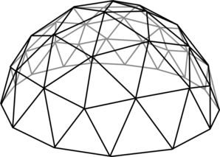
S | W |  | N | G
- 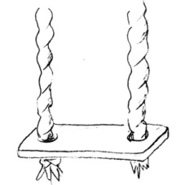
S | L | I | D
- 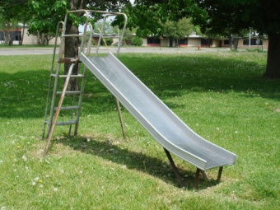
S | E | E | S |  | W

S | A | N | D | P | I
- 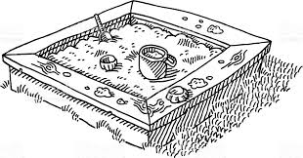
- Tick the correct answers 5X1=5

- Burger is from

America London

- ________is the colour of the middle band in flag of india

Saffron White

- After we sneeze we should say

Thank you Excuse me

- The pair word of needle is

Key Thread

- Momos are from

Tibet Italy

- Circle the fruit name and underline the vegetable name 10X1=10

Grapes Banana Carrot Apple Potato

Beans Orange Brinjal Mango Papaya

- Match the following
- 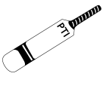 -

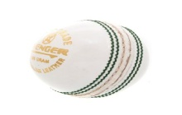

- -

- 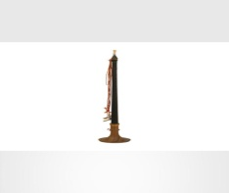 - 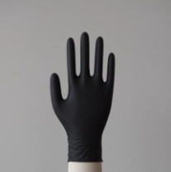

- - 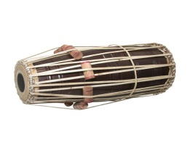

- Make a smiling face for the palite words and make a sad face for the unrefined words. 5X1=5

  - Good Morning b. Good Nigth c. Thank You

d. Sorry e. Lie

- Match different vehicles with their names. 5X1=5
A B

1. Auto -

Scooter picture
2. Bus -
Train Picture
3. Car - Auto Picture
4. Train - Car Picture
5. Scooter - Bus picture
VII. Draw the Flag of India and colour it 5X1=5

- Draw the picture of five fruits and colour 5X2=10

