BRILLIANT CBSE SCHOOL
PUDUKKOTTAI ULLUR
TERM – I
(2017 – 2018)
SUBJECT : G.K TIME : 2.00HR
CLASS : III MARKS : 50
- Fill in the blanks: 5X2=10
- Kashmir is in the ____________ of India.
- The large water bodies are known as _____________
- The largest continent in area is ______________
- The largest ocean is the _______________
- Chennai is in the _____________ of India.
- Choose the Correct Answers 10X2=20
- Capital of Andhra Pradesh ______________
- Chennai b. Jaipur c. Hyderabad
- Capital of Kerala is ___________
- Bombay b. Thiruvananthapuram c. Patna
- The sound that leaves make is called _________
- Pattering b. Gurgling c.Rustling
- The masculine gender word for niece’s___________
- Duke b. Nephew c. Bachelor
- How many days in a leap year _________
  - 366 b. 352 c. 340
- Young one of a BULL is called ____________
  - Cow b. Calf c. Hen
- Bones in our body is
  - 305 b. 206 c. 400

- Where you see this word “Silence please”
  - Library b.Railway station c. Car
- Capital of United states of America _________
  - Cairo b.paris c. Washington DC
- The sound that bell make it called
  - Chime b. Hiss c. Tick
- True or false 5X2=10
- Total letters of the English alphabet 26.
- Bharathanatiyam is the popular dance.
- Capital of Russia is Rome.
- Africa is the second largest continent in the world
- The “use Dustbin” sign is seen in a car.
- Match the following
- 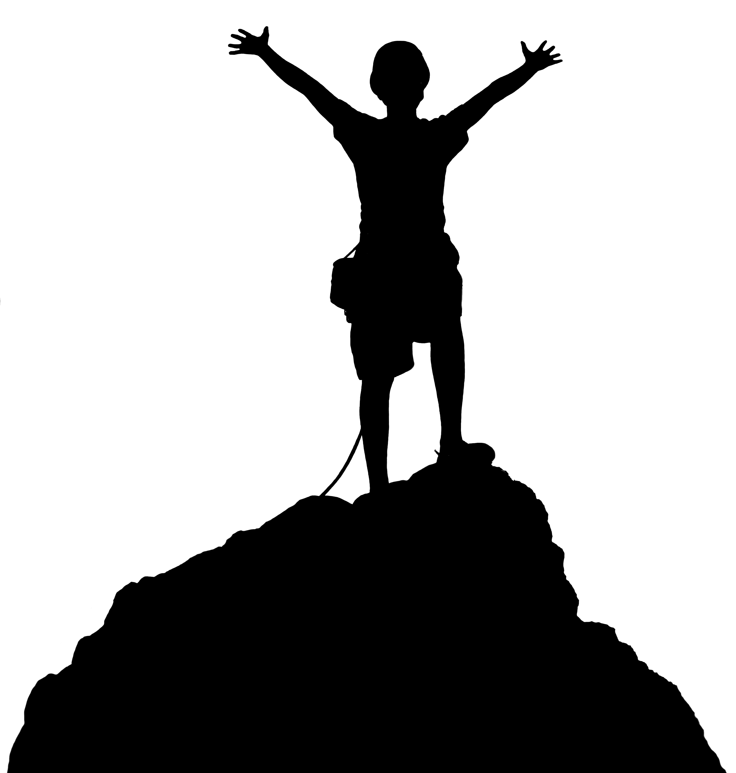 - Gandinagar
- 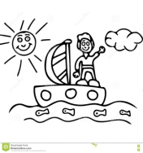 - Manipur
- 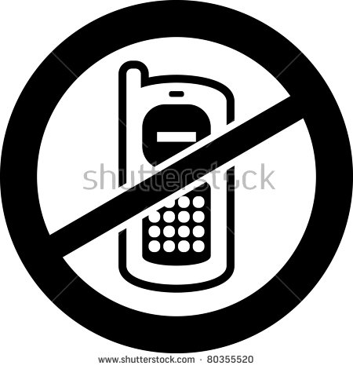 - Mare
- Gujarat - Weight lifting
- Manipuri - Bachelor
- 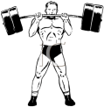 - Canberra
- Spinster - Rafting
- Horse - creak
- Australia - Mountaineering
- 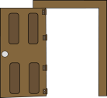 - Switch off your Mobile

