gpupypaz;l; rp.gp.v];., Nky;epiyg; gs;sp
GJf;Nfhl;il cs;@u; - 2017-2018
Kjy; gUtj; Nju;T

tFg;G : Kjy; tFg;G kjpg;ngz; : 80
ghlk; : jkpo; fhyk; : 2.30

- rupahd tpilia Nju;e;njLj;J vOJf

- Mj;jp R+bia vOjpatu;
m.ghujpjhrd; M. fz;zjhrd; ,.Xsitahu;;
2. gs;spf;$lk; tplÊL teÊjhyÊ gha;e;J tUtJ
m. eha;;; M. ML ,.fub
3. rpd;d rpd;dg; ge;J
m. rpWtd; M. rpWkp ,. ghg;gh
4. fpsp vt;thW fj;Jk; ___________
m. fPfP M.nyhs; nyhs; ,. nfhf; nfhf;
5. tz;z tz;zg; ge;J vq;Nf ghAk; __________
m. gf;fj;jpy; M. J}uj;jpy; ,. Thdpy;
II. Nfhbl;l ,lj;ij epug;Gf:
eha;> kPd;> $$....> fhfh> mzpy;

6. Fapy; vt;thW $Tk;
7. fhfk; vt;thW fiuAk;
8. goq;fis tpUk;gp cz;Ngd; KJfpy; %d;W NfhLfs; ,Uf;Fk; ehd; ahu;
9. jz;zPu;y; ePe;jp kfpo;e;jpLNtd; jiuapy; tpOe;jhy; Jbj;jpUNtd; ehd; ahu;
10. tPl;ilf; fhf;Fk; tpyq;F

III. nghUj;Jf: 5X1=5
11. 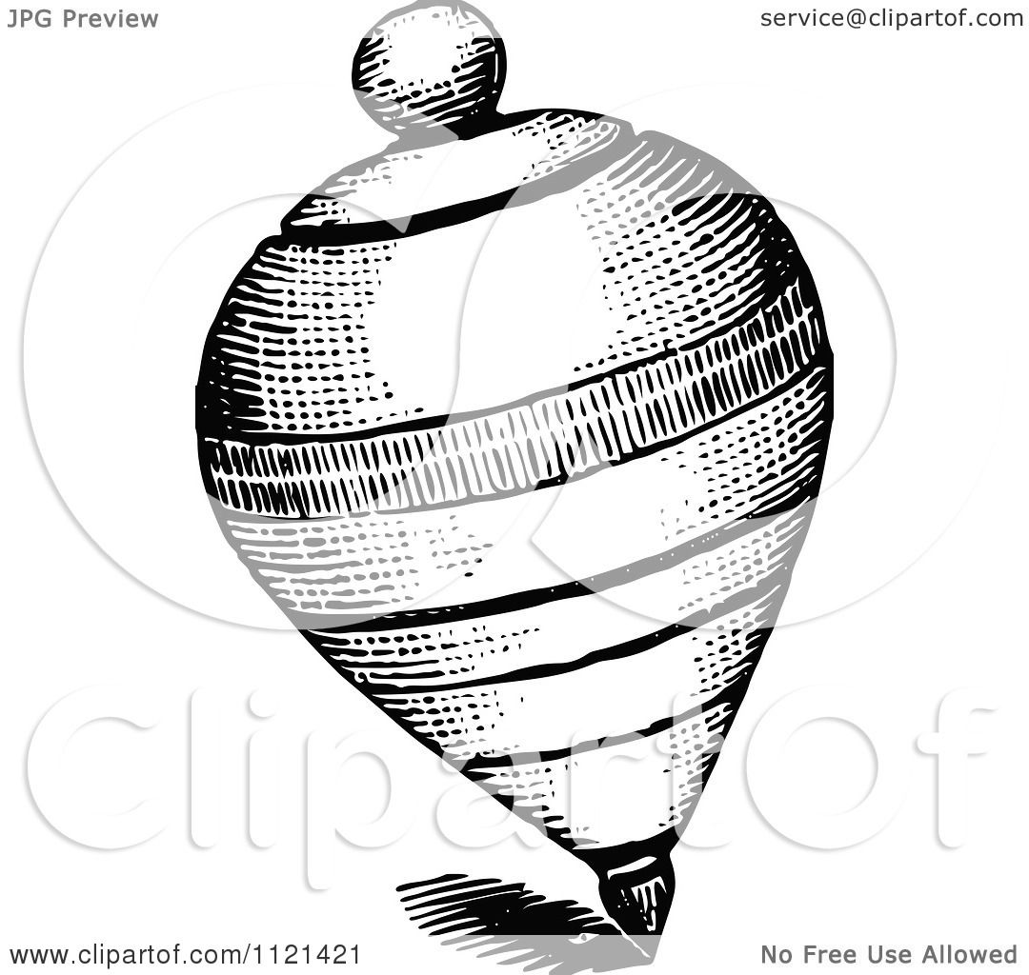 - gl;lk;
12. 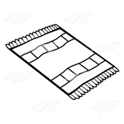 - kuk;
13. 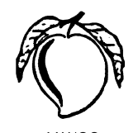 - gk;guk;
14. 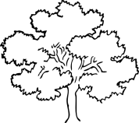 - gha;
15. 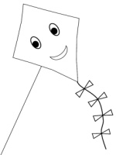 - khk;gok;

IV. tpLg;gl;l ,lj;ij epug;Gf: 5X1=5
16. ef 17. fu--------k; 18. --------j;jh
19. eh-------- 20. jr;r--------

V. Jiz vOj;ijr; Nru;j;J vOJf 5X1=5
21. efk; - ________________
22. gyk; - ________________
23. tuk; - ________________
24. fyk; - ________________
25. tdk; - ________________

VI. vOj;Jfis ,izj;J nrhy; cUthf;Ff 5X1=5

VII. njupahj vOj;ij tl;lkpl;L ePf;fp vOJf 5X1=5

31. gl;lzk; - ________________
32. kFlk; - ________________
33. gazk; - ________________
34. godk; - ________________
35. kJuk; - ________________
VIII. fl;lq;fspy; epug;Gf 5X1=5

