BRILLIANT CBSE SCHOOL
PUDUKKOTTAI ULLUR
TERM – I EXAMINATION (2017 – 2018)

SUBJECT : G.K TIME : 2.00HR
CLASS : V MARKS : 50

I. FILL IN THE BLANKS: 5 X 2 = 10
1. The galaxy to which our planet belongs is called______________
2. Milk teeth is a reference to ______________
3. India’s first IPS officer was ______________
4. The first Indian woman to climb Mount Everest is ______________
5. A place where rice is grown ______________

II. CHOOSE THE CORRECT ANSWER: 10 X 1 = 10
1.Which country’s old name was siam?
- Thailand b) Iran c) Indonesia
2.Which country is called ‘Nippan’?
a) Russia b) Japan c) China
3.The highest motorable road is located in which state?
a) Jammu and Kashmir b) Haryana c) Nagaland
4.Which is the southernmost point of India?
a) Rajiv point b) Indira point c) Bapu point
5. Before 2006, it was the ninth planet of the solar system
a) Ceres b) Ganymede c) Pluto
6.The word ‘Lunar’ is associated with this body
a) Sun b) Moon c) Comet
7.Which of these insects live in large social groups?
a) Silver fish b) Ant c) Fly
8.He discovered that the sun is at the centre of the solar system.
a) Marie curie b) Louis Pasteur c) Galileo
9.A narrow stretch of water connecting two big water bodies is a
a) Lagoon b) Delta c) Strait
10. A bee- keeper keeps in
a) a hole b) a nest c) an apiary

III. TRUE OR FALSE: 10 X 1 = 10
- You can also start running when the clothes catch fire.
- A chain of islands is called delta.
- National flower of Nepal is Rhododendron.
- The largest country in the world is china.
- A group of trees close together is called Orchard.
- A chain of Islands is called archipelago.
- During fire open the door to escape even if it feels hot.
- If you live in a building use the lift during fire.
- A shallow stretch of water, separated from the open sea by a barrier is a waterfall.
- Galileo discovered that the sun is at the centre of the solar system.

IV. MATCH THE FOLLOWING: 10 X 1 = 10
- The discovery of India - with passage of each day.
- Ain-i-Akbari - athletics
- Day by day - Galaxy
- Sachin Tendulkar - Swimming
- P.T Usha - Abdul Fazal
- Ian Thorpe - Pond
- Another name for a glow-worm - Jawaharlal Nehru
- Milky way - Cricket
- Most populous state - Unttar Pradesh
- A place where a lotus grows - firefly

V. Name Some Nation’s Pride
1.
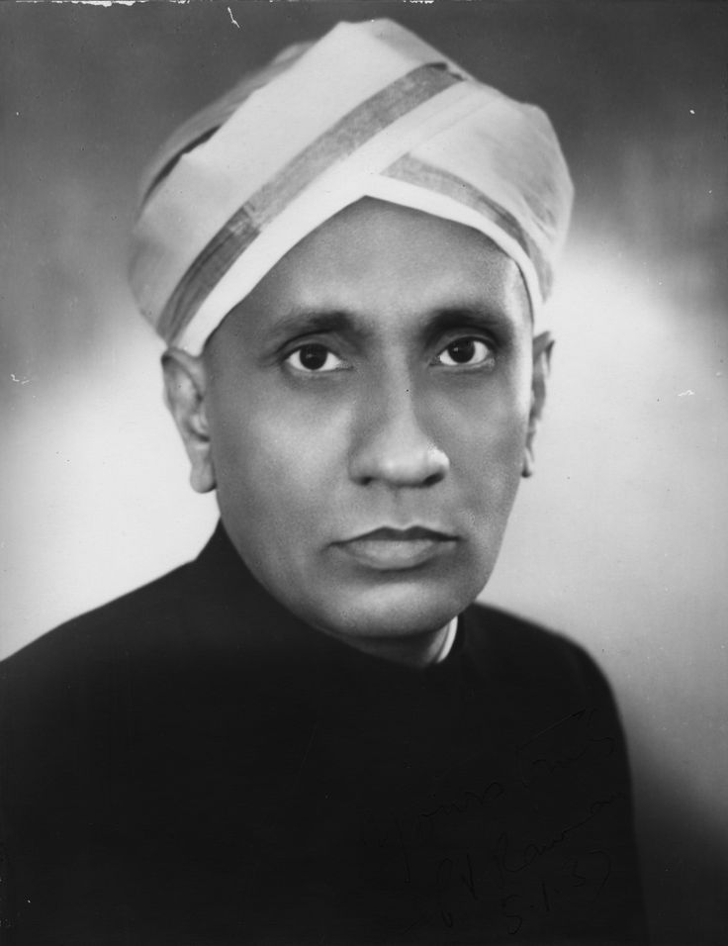

………………………………………..

2.
_________________

3. 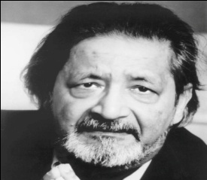

___________________

4. 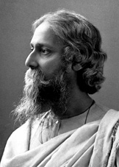
……………………………..

5. 


